**Market Basket Insights**

**Team member**

**952321106004:DEEPAN RAJ .A**

**Phase-1 Document Submission**

**Project: Market Basket Insights**

Objective:

To perform market basket analysis on a provided dataset to unveil hidden patterns and associations between products.

DATA SOURCE:

Dataset link: https://www.kaggle.com/datasets/aslanahmedov/market-basket-analysis

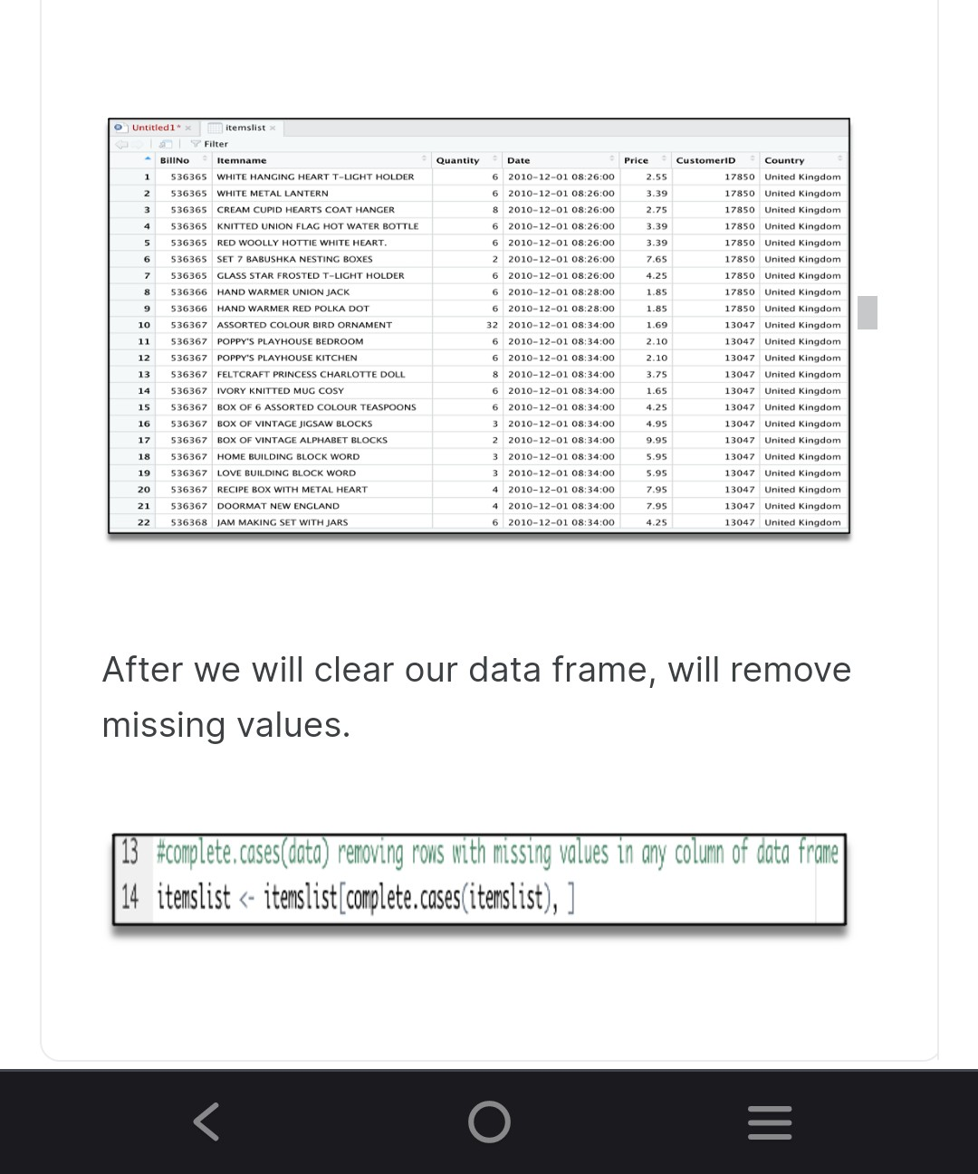

Programs:

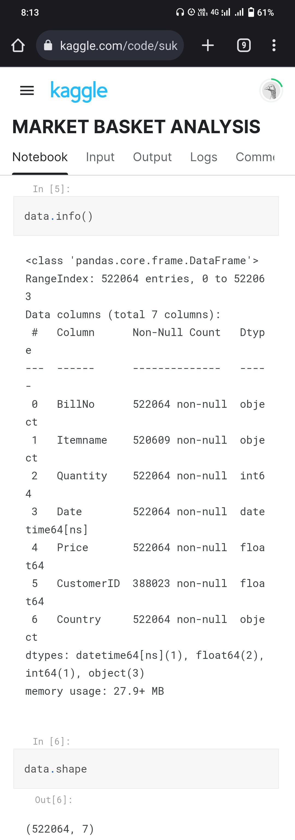

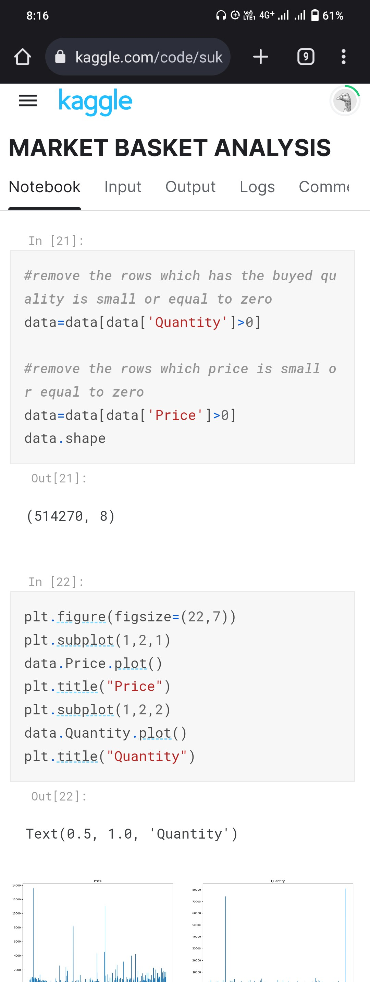

•Market Basket Insights is a data-driven approach aimed at extracting valuable knowledge from transactional data to enhance business strategies and customer experiences. This project presents a comprehensive framework for Market Basket Insights, comprising the following key modules:

1.Data Collection and Integration:

- This initial module focuses on acquiring and integrating transactional data from various sources, ensuring its quality and consistency. Data cleansing and transformation techniques are applied to prepare the dataset for analysis.

2.Exploratory Data Analysis (EDA):

- EDA plays a crucial role in understanding the dataset's characteristics. Statistical analysis and visualization are employed to uncover patterns, trends, and anomalies within the transaction data.

3.Customer Segmentation:

- To gain deeper insights, customer segmentation is performed based on factors such as demographics, purchasing behavior, or transaction frequency. This module uses clustering techniques to group customers with similar profiles together.

4.Association Rule Mining:

- This core module employs advanced algorithms like Apriori or FP-growth to discover frequent itemsets and association rules. These rules reveal hidden relationships between products and provide actionable insights for cross-selling and up-selling strategies.

5.Market Basket Analysis:

- Market Basket Analysis focuses on uncovering patterns of co-occurrence among products within customer baskets. This module calculates metrics such as support, confidence, and lift to identify significant product associations.

6.Recommendation Engine:

- An optional module, the recommendation engine, leverages the insights gained from the analysis to provide personalized product recommendations to customers. This enhances the shopping experience and drives sales.

7.Performance Metrics and KPIs:

- To measure the success of implemented strategies, key performance indicators (KPIs) are established. Metrics such as revenue uplift, conversion rates, and customer retention are monitored to assess the impact of Market Basket Insights on business outcomes.

8.Visualization and Reporting:

- Effective communication of insights is essential. This module focuses on creating visual dashboards and reports that convey the discovered patterns and recommendations to stakeholders, making data-driven decisions more accessible.

9.Continuous Improvement:

- Market Basket Insights is an ongoing process. This module emphasizes the importance of continuous monitoring, refinement of models, and adaptation to changing market conditions to ensure sustained business benefits.

Conclusion:

This framework empowers businesses to leverage their transactional data for informed decision-making, optimizing product assortments, and enhancing customer engagement. Market Basket Insights is a versatile tool with applications in retail, e-commerce, and various other industries, offering a competitive edge by uncovering hidden opportunities and improving overall business performance.